Diary Pages Sheet

**Map**

See Map Sheet

**Diary**

Every day gets two pages ->

QUESTION: Do I design the whole pages as png or do you need elements?

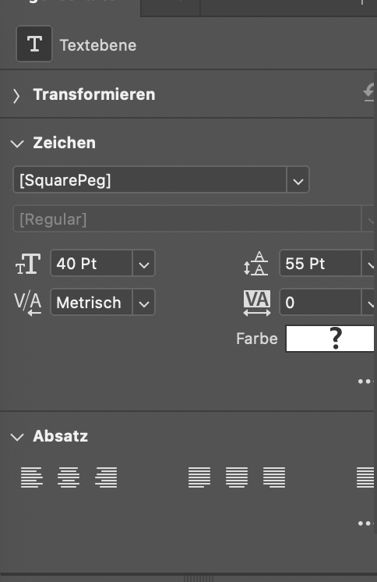 Font Settings Handwriting

**Interface**

2 pages, 3 bags

Interface Elements like Bags: <https://drive.google.com/drive/folders/1aRxk0ATFRxxsDVNjq6cpDrGfe_ce-GER>

**Health Conditions**

2 Pages for Main Characters

2 Pages for Info

-> TBA

**Settings/Credits**  
TBA